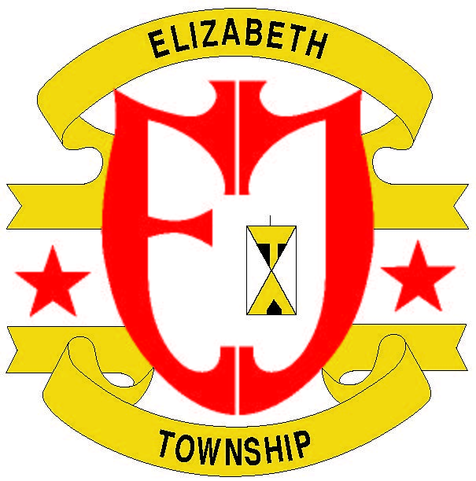
ELIZABETH TOWNSHIP
522 ROCK RUN ROAD • ELIZABETH, PA 15037
PHONE 412-751-2880 • FAX 412-751-6002
www.elizabethtwppa.com

Floodplain Development Information
Floodplain Insurance
The National Flood Insurance Program (NFIP) provides flood insurance to individuals at much lower premiums than could otherwise be purchased through private insurers, and makes certain federal monies available to local communities. In order for citizens to be eligible for the national flood insurance rates, or for communities to receive certain kinds of federal monies, the community must agree to meet minimum floodplain standards. The Floodplain Development Permit Application is a tool to ensure that the minimum standards are met.
In a participating NFIP community, like Elizabeth Township, flood insurance policies can be purchased from any local insurance agent at the national rate. Even though the policy may be issued as if it were coming from the insurance company you deal with, it is actually a Federal NFIP policy printed on the insurance agency’s letterhead. The rates are determined by the flood risk zone in which you live and by the elevation of the lowest floor of your home, not by the insurance company, and should be the same regardless of which agent or agency sells you the insurance. You may buy flood insurance for your own peace of mind, you may be required to buy it before a lending institution will make or refinance a loan, or you may not be buying flood insurance at all.
Floodplain Development Permits
If the property you propose to develop is located within a “Special Flood Hazard Area” on a map issued by the Federal Emergency management Agency (FEMA), you MUST obtain a Floodplain Development Permit prior to beginning the project. This is a requirement of the Elizabeth Township Floodplain Ordinance and there are penalties for failing to obtain a permit.
Floodplain Development Permits are ONLY required for developments in areas designated as “Special Flood Hazard Areas” of FEMA-issued flood maps. Flood maps can be reviewed at the office of the Elizabeth Township Floodplain Administrator, or viewed online at the FEMA website www.FEMA.gov.
If you are proposing a development of any kind in a floodplain, you MUST submit an application for Floodplain Development Permit to the Elizabeth Township Floodplain Administrator. Depending on the type of development you are proposing, additional forms may be required. For example, all new buildings in a Special Flood Hazard Area require an Elevation Certificate to document that the lowest floor of the building is elevated to a certain height relative to the anticipated flood crest of the “base flood” event. The Floodplain Administrator reviews submitted applications and determines weather of not additional forms is needed. If additional forms are needed, the Floodplain Administrator will request the additional information from the applicant.
Once all materials are submitted, the Floodplain Administrator will make a permitting decision and either issue or deny the requested Floodplain Development Certificate. Applicants may appeal denied permits per the provisions of the Elizabeth Township Floodplain Ordinance.
The applicant should understand that a Floodplain Development Permit is a permit to complete only the proposed development. It is a permit to, for example, build a house, construct a baseball field, install a drainage ditch or septic system or grade a parcel of land. Before the house can be occupied, or developed land used, the Floodplain Administrator must issue a Compliance Certificate. The Floodplain Administrator will perform an inspection after the project is completed, or perhaps several inspections throughout the progress of the project, to make sure that the development is compliant with the requirements of the Elizabeth Township Floodplain Ordinance. Once the Compliance Certificate has been issued, the process is complete.

